1. Create a folder named Cooking

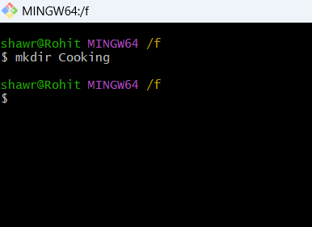

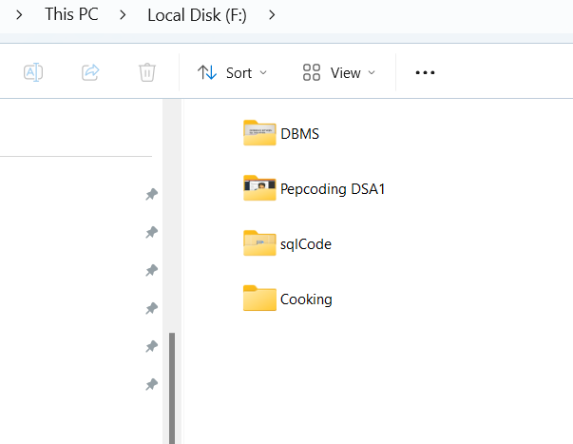

1. Make three sub folders vegetables, fruits, and grains

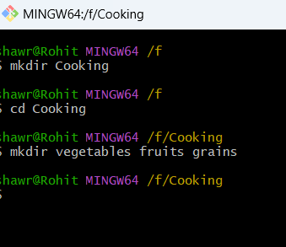

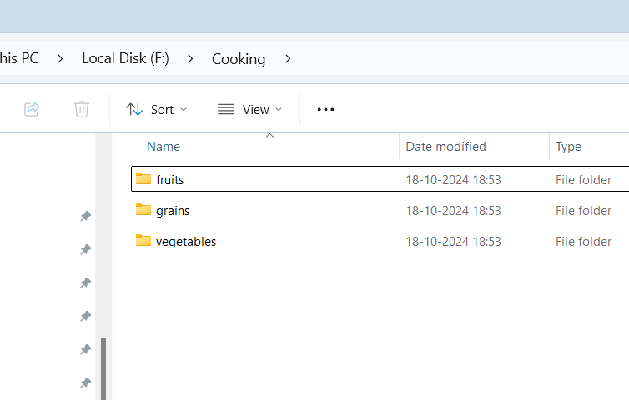

1. Use command line to check all folders in Cooking folder

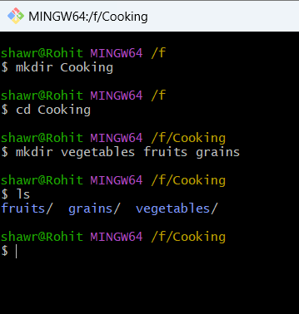

1. Navigate to vegetable folder using command line

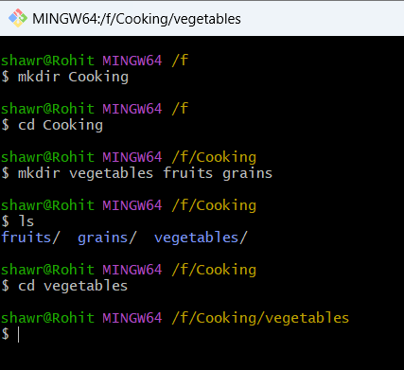

1. Make these 4 files potato.txt, apple.txt, rice.txt and water.txt in vegetable folder